Experiment No. 1

Familiarization with Networking Commands

NAME: Shirish Manoj Bobde

Reg. No.: 812

Roll No.: ECE/21152

AIM: To study the basic networking commands.

APPARATUS (Software): Linux OS and Terminal.

TASKS:

1. Install net-tools using **sudo apt install <package name>**

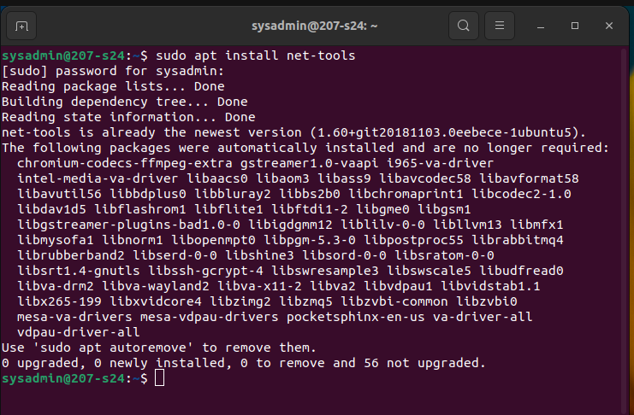

1. Use a command to display the name of your computer.

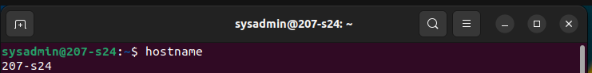

1. Use a command to check whether a system is connected to a network or not.

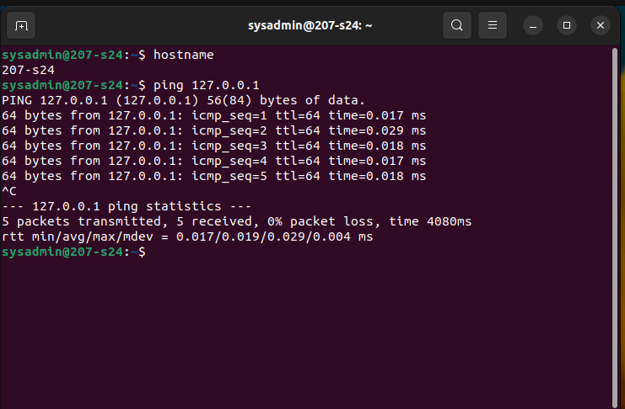

1. Use a command to display statistics of your network.

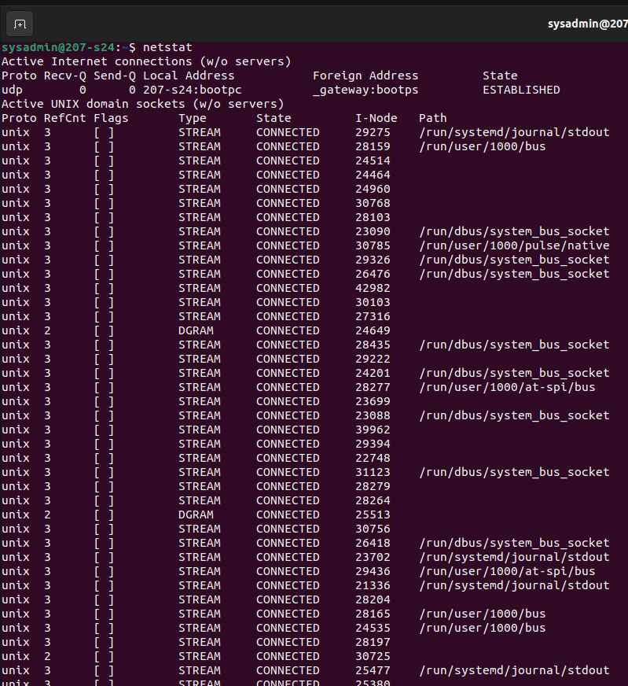

1. Use command **arp.**Check the result and explain the role of arp.



The arp command is used to access the mapping structure of IP addresses to the MAC address. This provides us with a better understanding of the transmission of packets in the network channel. [ arp -a displays the mapping of IP addresses to their corresponding MAC addresses.]

1. Use the command **ifconfig.**Check the result and explain the role of ifconfig.

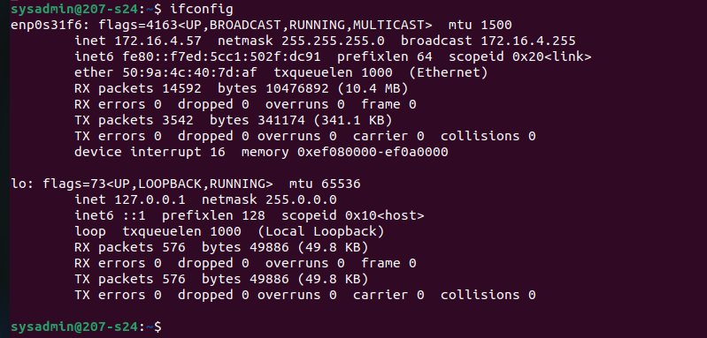

The ifconfig network command provides a collective view of information regarding the IP address configuration of the device we are currently working on.

1. Use the command **nslookup**. Check the result and explain the role of nslookup.

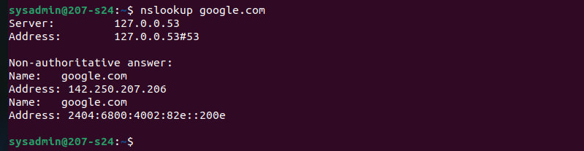

The nslookup command in Linux is used to query DNS servers and get information about domain names and their corresponding IP addresses.

1. Use the command **tracepath.**Check the result and explain the role of tracepath.

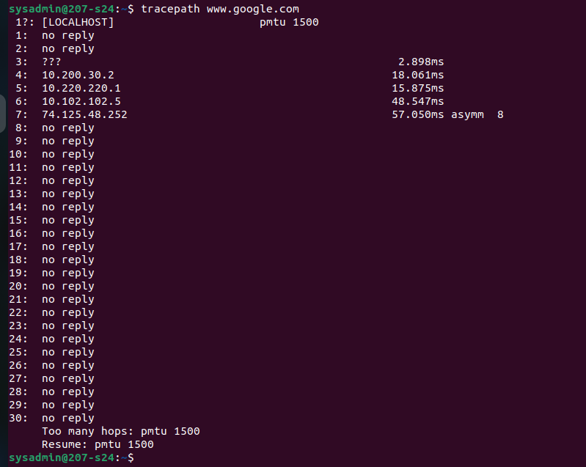

The tracepath command is used to trace the path from the origin to the destination. Each line in the tracepath output represents a router (hop) that the packet passes through.